SMART SEWAGE SYSTEM USING IOT

Vivek Chauhan

Electronics and Communication Engineering

Bharati Vidyapeeth’s College of Engineering, New Delhi

***ABSTRACT*: This paper discusses smart sewage system from three aspects, quantitative and qualitative nature of sewage, discovery and detection of failure points and mitigating or controlling actions taken. The paper proposes novel project for addressing the problem of sewage overflow due to clogged sewers using Internet of Things. The sustainability of system and different topological considerations are kept in while designing. This project outlines the communication methods utilized to provide secure data transmission taking into consideration the power efficiency. Process of data aggregation and storage in regards to methods and tools employed for carrying out analytics is also discussed. Features of trigger and alert generation are included in project to facilitate the corrective measures.**

***KEYWORDS: IOT, SMART SEWAGE SYSTEM, WIRELESS SENSOR NETWORK (WSN), CLUSTERING***

1. INTRODUCTION

Wherever a sewer system exists, so does the potential for overflow. Most sewage overflow occurs when sewer lines are blocked by roots, debris, grease or due to breakage in line .This poses threat of contamination of drinking water, act as a breeding ground for mosquitoes and leads to various health hazards, so it is imperative to address the issue of sewage and sludge that is invisible and that flows beneath the ground we walk upon, in our drains and into our water bodies. Also, no city can be termed truly ‘Smart’ without an effective sewage management system in place and hence the need for Smart Sewage System is underlined. This paper has focused on discussing robust operating models and new approach to sanitation planning for providing holistic solution for sewage management. This project is focused on detection of point of failure and leakage with high accuracy to analyze and establish the risks associated with different type of waste in sewerage system. It is an IOT enabled model to carry out run-time detection on node basis. IOT is defined as the mesh of interconnected devices capable of decision making and transmitting the data to other connected devices always, anywhere and at all times.IOT provides an ecosystem for the data aggregation, data forwarding as well as for actuator action. The proposed model goes on to determine the area use from difference quantitative values of data and detecting suspicious activities based on qualitative values of data collected. The model proposes to equip manholes with sensors that communicate through gateway to remotely located servers. The sensors can measure water levels, detect ph and oil per water ppm. The soap lathers used in industries and use of sensitive ion electrode based sensors that can detect certain explosive chemicals in sewage by deploying sensors throughout the sewer line infrastructure keeping in mind topological and geographical considerations are considered. Monitoring and trigger management capabilities are also developed into the system to further reduce the human interdependence for fault detection and communication.

1. RELATED WORK

Drainage system is a critical link in smart city infrastructure and work is being done to address the concerns related to drinking water contamination and detecting poisonous gases from sewer. The existing system does not address the qualitative nature of sewage responsible for clogging. Most systems prevalent uses pressure flow alone as standard metric to calculate drainage water and sensors are used in isolation with no fallback mechanism. The controlling aspects are also not discussed in existing text. The communication system mostly used are GSM modules ,RFID with recent research including the ZigBee, Wi-Fi and cloud capabilities, but these research does not discuss the power-distance trade off involved. Node wise reliance compared to system are also missing. Tremendous advancement is made towards providing single platform for analytics and alerting capabilities. Topological and demographic distribution plays an important role in devising such systems while many papers discussing such solutions in isolation to Greenland projects or Smart city environment which is currently not the case. The capability of nodes to cluster and take requisite actions for power management is discussed in other texts in isolation which have included in our project.

1. SYSTEM ARCHITECTURE

The system is arranged in master-client model with secondary node acting as master and primary node as client. Secondary node has pumping motor in addition to primary nodes. The components in primary node are discussed as below:

Pressure Sensor: Pressure is converted into displacement. The sensors then convert this displacement into electrical output such as current or voltage. The most common pressure sensors are the strain gage, variable capacitance, and piezoelectric. The output voltage is in range of few mV so either these valued need to be conditioned to 0-5V signal or 4-20mA. These signals can then be measured using standardized multi function data acquisition hardware. This sensor can also be used to measure the level of sewage/water in the sewer.

Level Indicator: Flow sensor or resistor based sensors are used to ascertain the flow rate and level of water. Flow sensors are based on Hall Effect. Here, the Hall Effect is utilized in the flow meter using a small fan/propeller-shaped rotor, which is placed in the path of the liquid flowing. The liquid pushes against the fins of the rotor, causing it to rotate. The shaft of the rotor is connected to a Hall Effect sensor. It is an arrangement of a current flowing coil and a magnet connected to the shaft of the rotor, thus a voltage/pulse is induced as this rotor rotates. In this flow meter, for every L of liquid passing through it per minute, it outputs about 4.5pulses. This is due to the changing magnetic field caused by the magnet attached to the rotor shaft as seen in the picture above. We measure the number of pulses and then calculate the flow rate in (L/hr) using a simple conversion formula.[]

Electrolyte: When explosive chemical in the drain reacts with the electrolyte suspension, a resistive strip arranged in Wheatstone bridge is calculated and a value based on reactive property of chemical detected converts to electrical signal (voltage).

Poisonous gas sensor: Methane, Carbon monoxide (CO) or phosphorous gases are hazardous and could be measured using MQ-4, MQ-7 or MQ-9 gas sensors. These sensors are based on the sensitive SnO2 which increases the conductivity as concentration of CO increases. A simple electrical circuit is used to translate these changes into electrical outputs. It is a low-cost sensor and can be employed in diverse applications.

Pumping motor: Micro DC 3-6V Micro Submersible Pump is used in our project which can work with 3-6V power supply. It can take up to 120 liters per hour with very low current consumption of 220mA.

Node MCU: It is A LUA based microcontroller with SoC ESP8266 Wi-Fi module and multiple GPIO pins. It has event-driven API for network capabilities. Each device is unique with its IP. It is used as it has the capability of being host as well as client and allows for inter-communication using SPI and I2C communication.

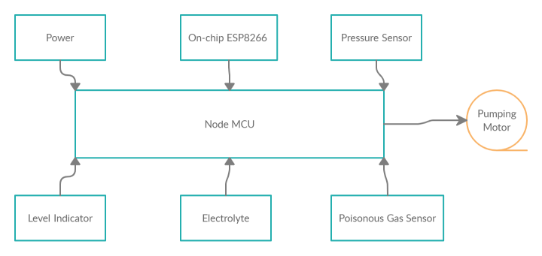

1. Secondary Node Module Block Diagram

MQTT(Message Queuing Telemetry Transport) :It uses Pub-Sub and converts message between sensors and application. The data is transmitted to server (referred as Broker), called as publish, this is shared on secure topic and devices subscribed to that topic with authorization are able to receive that information and using IFTTT is able to act on data.

IFTTT: If This Then That allows for providing conditional test conditions which can be triggered based on the changes occurred on web service. When message is received at ‘Topic’ for clogging or leakage, it is able to send emails to concerned authority without going through the need for to reach through Cloud to Centralized control. It is used only in the case when system fails to power ON nodes.

Cloud: We used Google Cloud Platform (GCP) free edition for our purpose and pushed logs to storage in InfluxDB. Configuration of heartbeat, MQTT, (Quality of Service) QoS and Acknowledgement is easy and provides a transparent overview of system performance.

Data Storage: InfluxDB is used as a storage engine owing to its Write Ahead Log (WAL) and Time series Index (TSI) components. Data is written using line protocol sent via HTTP post request. As data grows over time ,queries might become slower but InfluxBD maintains data cardinality as data grows. The data series are stored based on measurement labels and tags, hence it is easier to query data.

Analytics and Alerting: Grafana provides rich support for visualization and alerting. Data storage can be configured and data is updated at real-time. It is an efficient way to represent system metrics. Alerting and trigger management is easily managed through its GUI. Manual threshold values are given and endpoints for sms and mail generation could be easily streamlined in it. We used Grafana as it provides easy to manage dashboards with queries written in QL or JSON format.

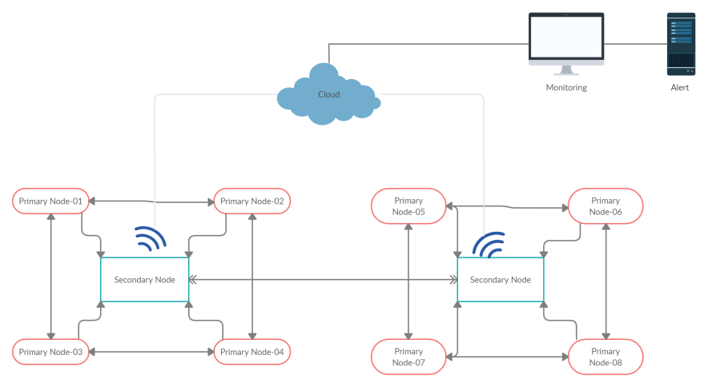

1. Mater-client communication with Cloud network diagram
2. WORKING

The wireless sensor network in the proposed model is structured and static owing to the fixed topology which is based on the geographical topology of the area in which it may be employed. The nodes are clustered so as to increase the network reliability and stability. The primary nodes are responsible for carrying data aggregation and data processing where as the secondary nodes are merely responsible for forwarding the data it senses from the surroundings. The model is aimed at reducing the load capacity at secondary nodes for longer life of network. The primary nodes accumulates the data and performs basic comparison operations while secondary nodes control the actuator action and transmitting this data from nodes to server stations for further data analysis and modelling. The primary nodes make use of energy harvesting and the residual energy on each cluster head of primary node determines the capability and capacity of node to operate before it becomes dead in the network. At the secondary node, multiple sensors can be used namely, an electrolyte for specific chemicals to test for presence of explosive chemicals from that area, grease and oil per ppm standardized sensors to check for regularising the area usage (that is certain limits are set for oil and grease in industrial areas ,residential areas , etc) ,a level indicator and pressure sensor are used at these nodes to determine the safe levels of sewage in that area and calculate probability of clogging in that particular area. The pressure level and level indicator can be used to ascertain accurate point of leakage in line by measuring the pressure difference between two nodes. The aforesaid sensors are used to sense quality and quantity of sewage waste but do not provide any corrective measures for it. For corrective purposes, a pumping motor is used at designated nodes to direct the sewage from different paths (if any possible) in network topology otherwise just pumps with greater pressure. The sensors sense the data and forward it to primary nodes for further action which either triggers the secondary nodes to take an action or simply transmits it to the server station. The data comparison is carried out with pre-determined reference values. Pings or alerts are generated when this limit is breached. The clustering is done at the IPv4 network via ESP8266 module and secondary node transmit data using MQTT protocol which is on top of TCP/IP stack to cloud for further analysis and modelling at server. The data is transmitted using Publish-Subscribe model via the gateway by connecting to the web socket. The whole network is crypted and nodes connect to only specific default networks using username and passwords on secure ‘topics’ only. Every node has different usernames and passwords and hence this unique identification of nodes is basis for determining the actual point of failure in the network. There is capability of hoping and connecting to other neighbourhood nodes in case of an immediate node failure. A dedicated dashboard showing the status of all active nodes in network is maintained. It is at this node that data collected from nodes is analysed and plotted on graphs for better visualization and understanding.

1. PROCESS FLOWCHART

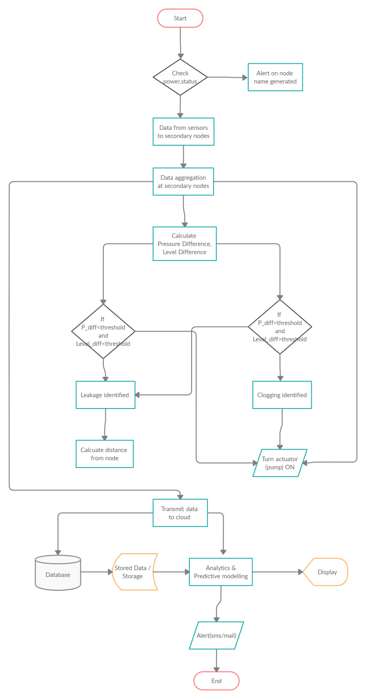

1. Working flow chart
2. RESULT

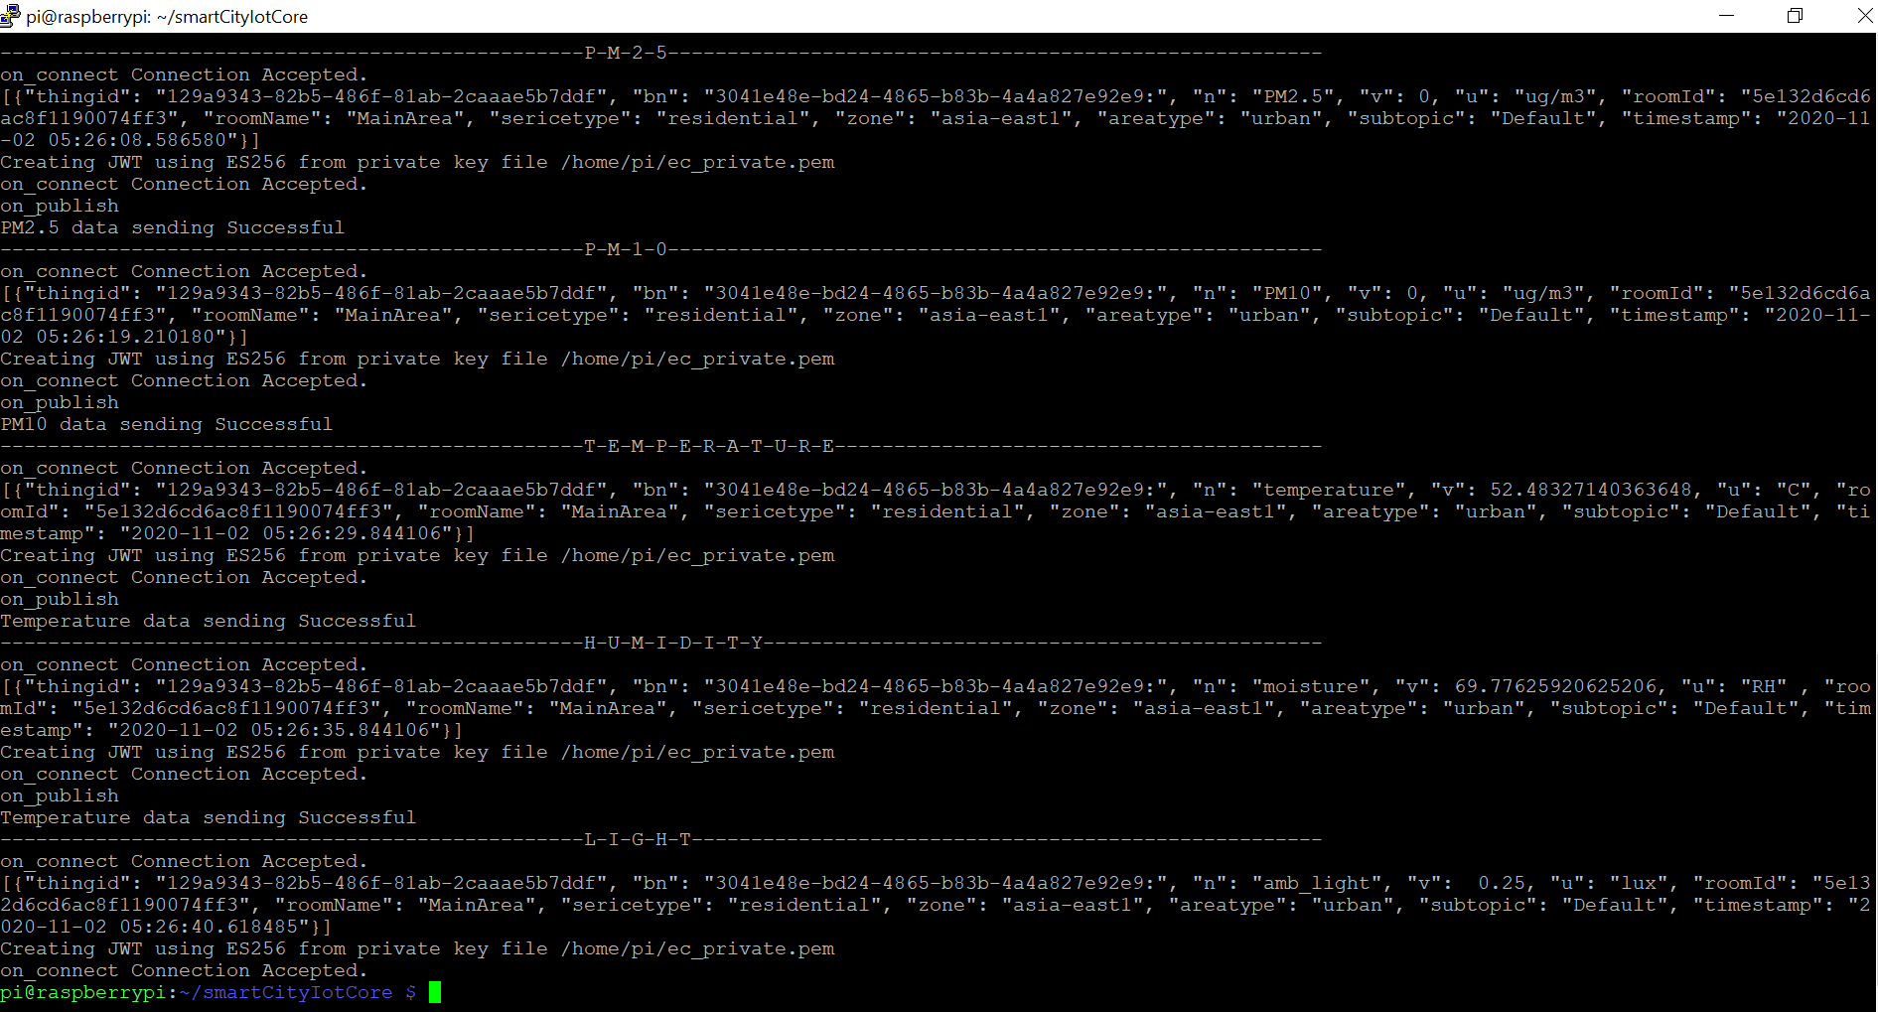

1. Log of sensors data

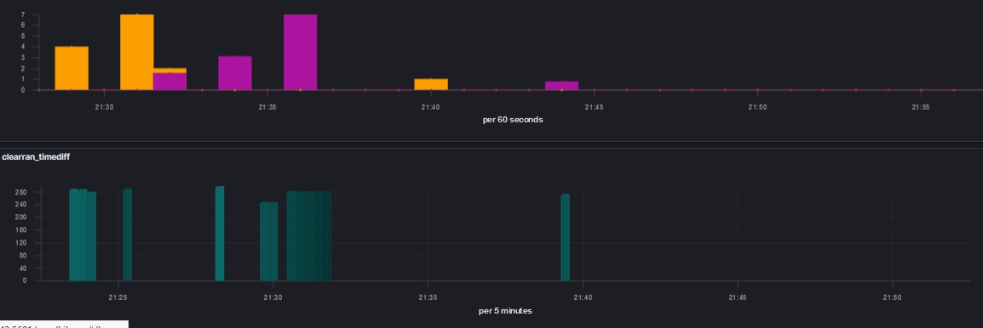

1. Grafana visualization of data points plotted for pressure and level against time series

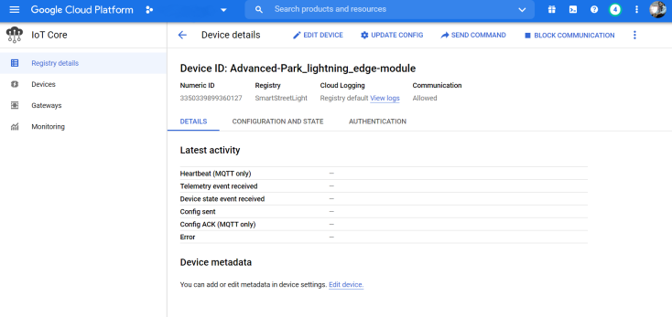

1. GCP monitoring window for all all smart city related projects
2. CONCLUSION

With increasing urbanization there is increased stress on drainage system so there is a need for smart and efficient sewage system. Detection and preventative maintenance will enhance the sewage system capacity; improve the flow of water inside of drainage channels and help the system from being overwhelmed during heavy rains. The smart sewage system will reduce the human effort and human dependence. This will lead to a clean and safe environment. The life time and power consumption of WSN is critical for smooth functioning of system and so energy reduction per head by employing various WSN clustering techniques is of future consideration. The use of renewable energy resources as a means of power supply is being investigated and the composition of chemical electrolytes is under study for optimum results. The use of a secure gateway, immune to wifi-jammers is to be utilized in future.

1. REFERENCES
2. P. Sotres, J.R. Santana, L. Sánchez, J. Lanza and L. Muñoz, "Practical lessons from the deployment and management of a smart city Internet-of-Things infrastructure: a case", IEEE Access, 2017.
3. S. Sholla, R. Naaz and M.A. Chishti, "Ethics aware object oriented smart city architecture", China Communications, vol. 14, pp. 160-173, 2017.
4. M. S. Hossain, S. A. Hossain, A. Alamri and M. A. Hossain, "Ant-based service selection framework for a smart home monitoring environment", Multimedia Tools Appl., vol. 67, no. 2, pp. 433-453, 2013.
5. J. Jin, J. Gubbi, S. Marusic and M. Palaniswami, "An Information framework for creating a smart city through Internet of Things", IEEE Internet of Things Journal, vol. 1, no. 2, 2014.
6. M. Jensen, J. Gutierrez and J. Pedersen, "Location intelligence application in digital data activity dimensioning in smart cities", International Conference on Complex Adaptive Systerns, 2014.
7. N. Li, D. Liu and S. Nepal, "Lightweight mutual authentication for IoT and its applications", IEEE Transactions on Sustainable Computing, 2017.
8. M. Coccoli, A. Guercio, P. Maresca and I. Stanganelli, "Smarter universities: a vision for the fast changing digital era", Journal of Visual Languages & Computing, vol. 25, pp. 1003-1011, 2014.
9. S. Elmaghraby and M. M. Losavio, "Cyber security challenges in smart cities: safety security and privacy", Journal of Advanced Research, vol. 5, no. 4, pp. 491-497, 2014.
10. Negash, A.M. Rahmani, T. Westerlund, P. Liljeberg and H. Tenhunen, "Lisa: lightweight internet of things service bus architecture", Procedia Computer Science, vol. 52, pp. 436-443, 2015.
11. P. Sakhardande, S. Hanagal and S. Kulkarni, "Design of disaster management system using IoT based interconnected network with smart city monitoring", International Conference on Internet of Things and Applications (IOTA), pp. 185-90, 2016.
12. Yaqoob, I. A. T. Hashem, Y. Mehmood, A. Gani, S. Mokhtar and S. Guizani, "Enabling communication technologies for smart cities", IEEE Communication Magazine, vol. 55, no. 1, pp. 112-120, 2017.
13. [Minoli, K. Sohraby and B. Occhiogrosso, "IoT Considerations requirements and architectures for smart buildings-energy optimization and next-generation building management systems", IEEE Internet of Things Journal, vol. 4, no. 1, pp. 269-283, 2017.
14. C.H. Lee and Y.H. Lai, "Design and implementation of universal smart energy management gateway based on IoT platform", IEEE International Conference on Consumer Electronics, 2016.
15. W. Ejaz, M. Naeem, A. Shahid, A. Anpalagan and M. Jo, "Efficient energy management for the Internet of Things in smart cities", IEEE Communications Magazine, vol. 55, pp. 84-91, 2017.
16. K.Viswanadh,P.Rojitha,S.K.Khadija,M.S.P.C.Venkataraju,P.Nagamani "Under Ground Drainage Monitoring System Using IoT" Journal of Emerging Technologies and Innovative Research, Volume 6, Issue 4, April 2019